Circus Of Plates

Report

A game developed by:

* **Ahmed Nabil Mohamed Anwar** (7)
* **ElSayed Abdel-Nasser ElSayed** (10)
* **Ziad Hisham Ali Abdel-Hameed** (19)
* **Yehia ElSayed Mohamed** (59)
* **Youssef Ahmed Sayed Gabriel** (61)

1. Description:

It’s a single player game where there’s a clown carrying two sticks with plates falling from above and he is trying to collect as many 3 consecutive plates of the same color as he can with 3 different difficulty levels and cool special gifts for him to collect.

1. Design:

* Sequence Diagrams:

The player collects 3 consecutive shapes of the same color and the state of the stacks is saved using snapshot design pattern.

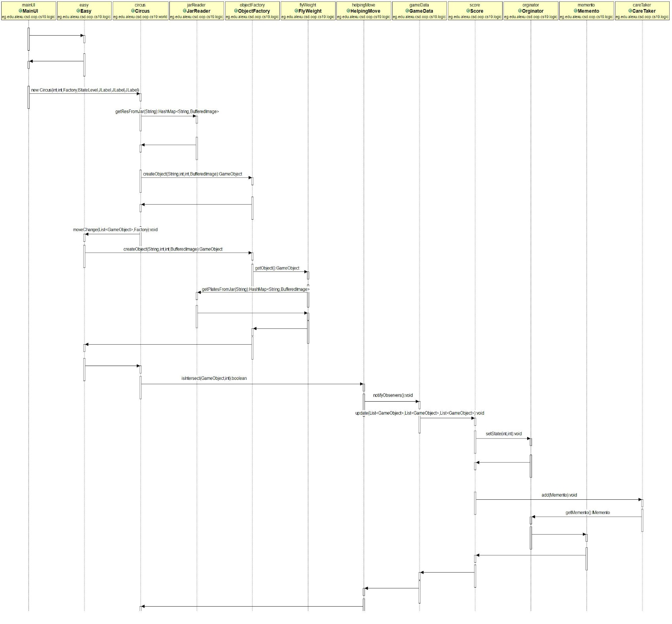

The player collects a bomb so the stacks he is carrying returns to the last state where he collected 3 consecutive shapes of the same color using the snapshot design pattern.

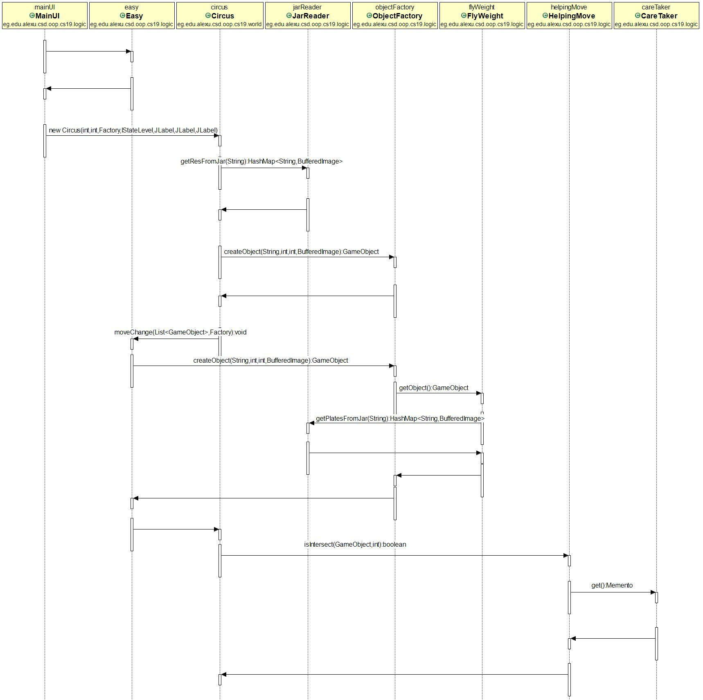

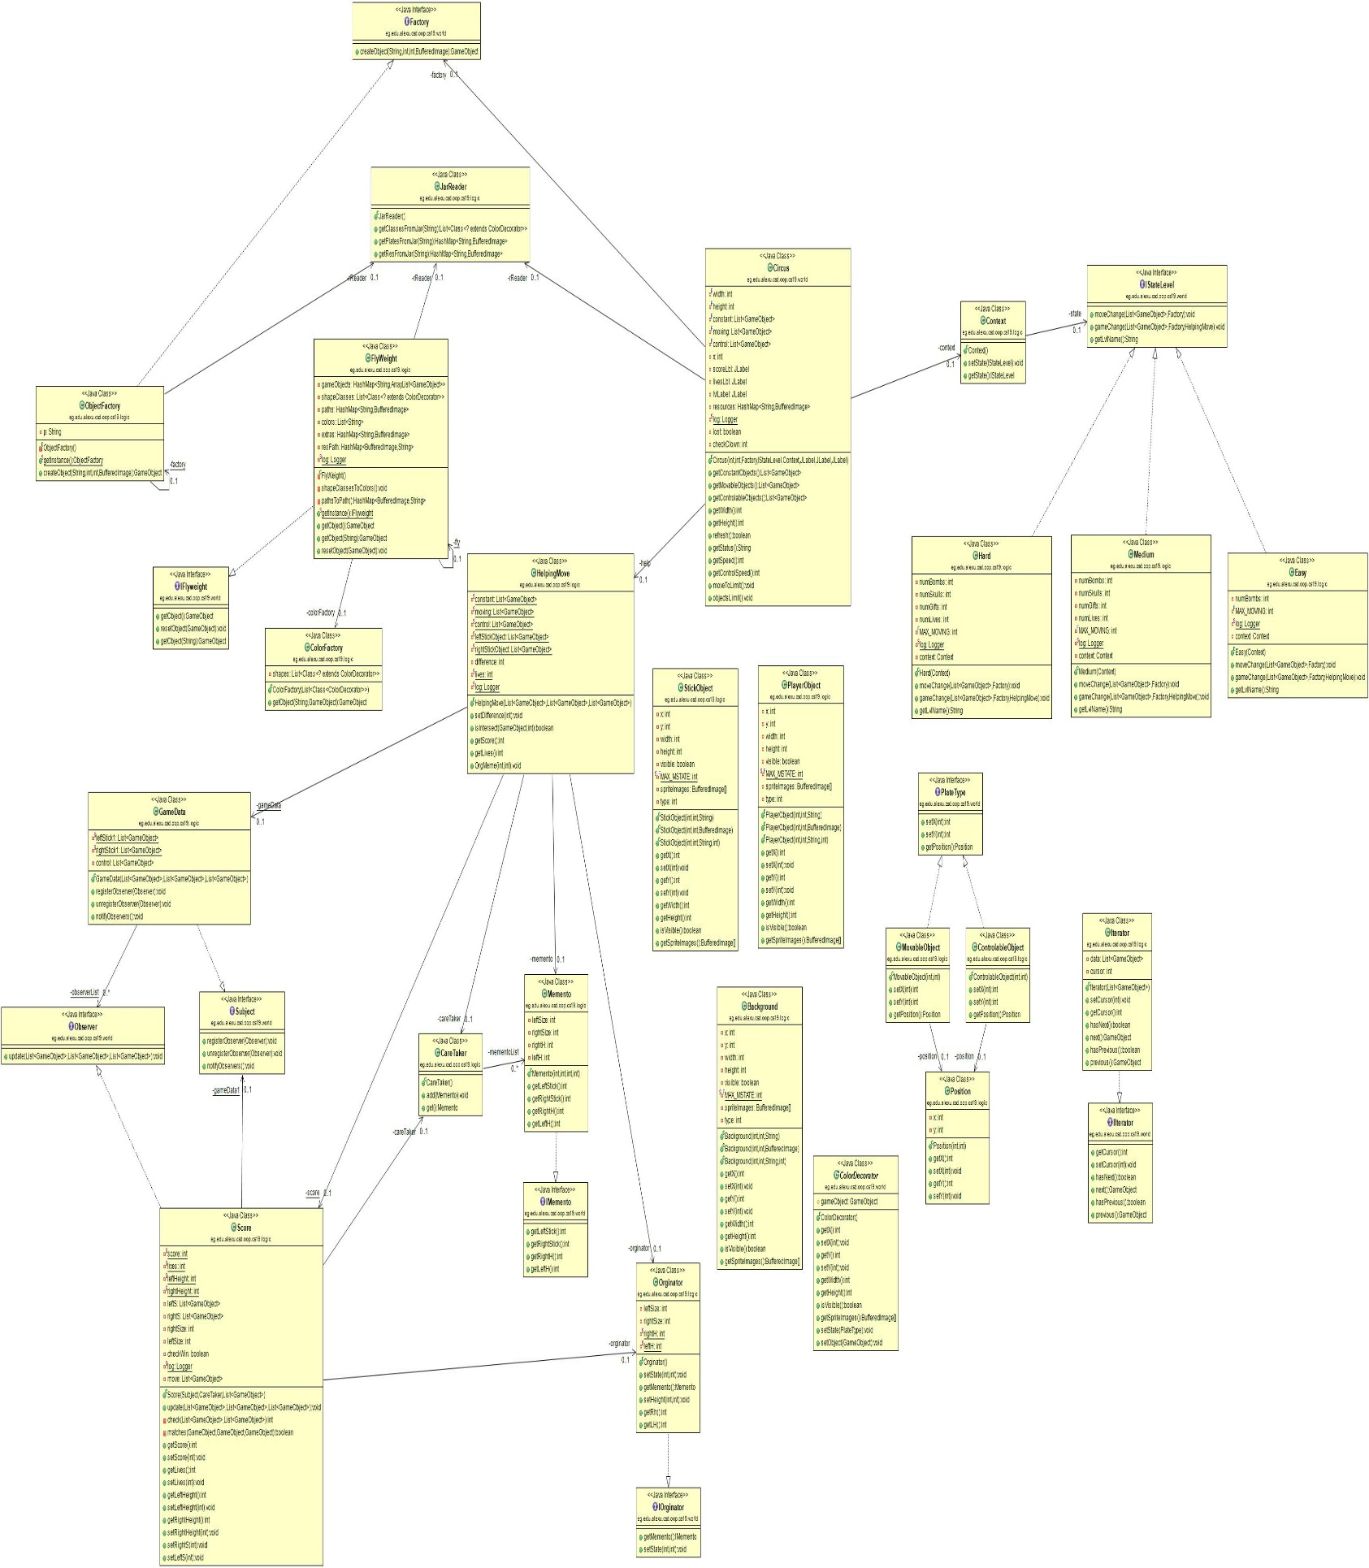

* Design Patterns:

1. Singleton:

We used the singleton in the Factory that creates new shape objects and in the flyweight class that holds the expensive data we use.

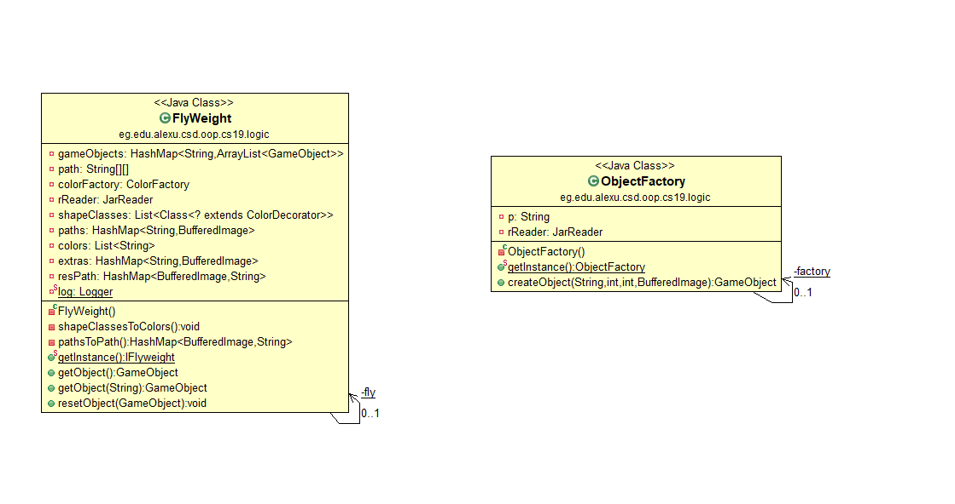

1. Factory:

We used the factory design pattern to create new shapes with the required data.

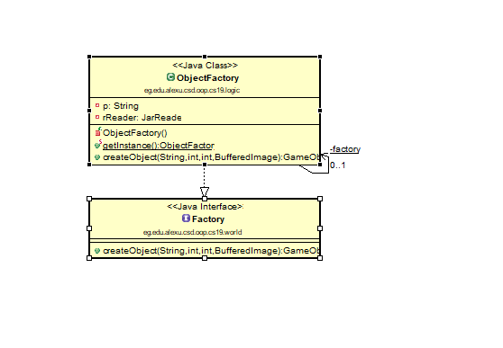

1. Iterator:

We used the iterator design pattern to iterate through different lists that we used in the game.

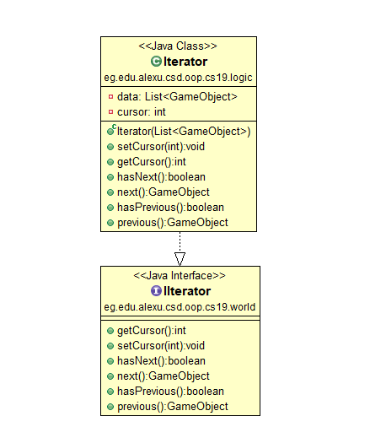

1. Dynamic Linkage:

We used the dynamic linkage to load the different shapes classes and to load the images we use in the game from jar files.

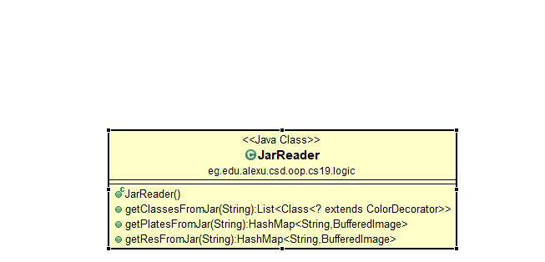

1. Snapshot:

We used the snapshot design pattern in saving the current stacks data to use it when the player collects a bomb to make him return to the last winning stacks.

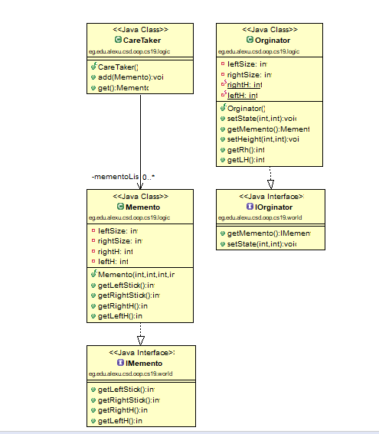

1. State:

We used the state design pattern in the level system where each level performs the refresh on the shapes differently.

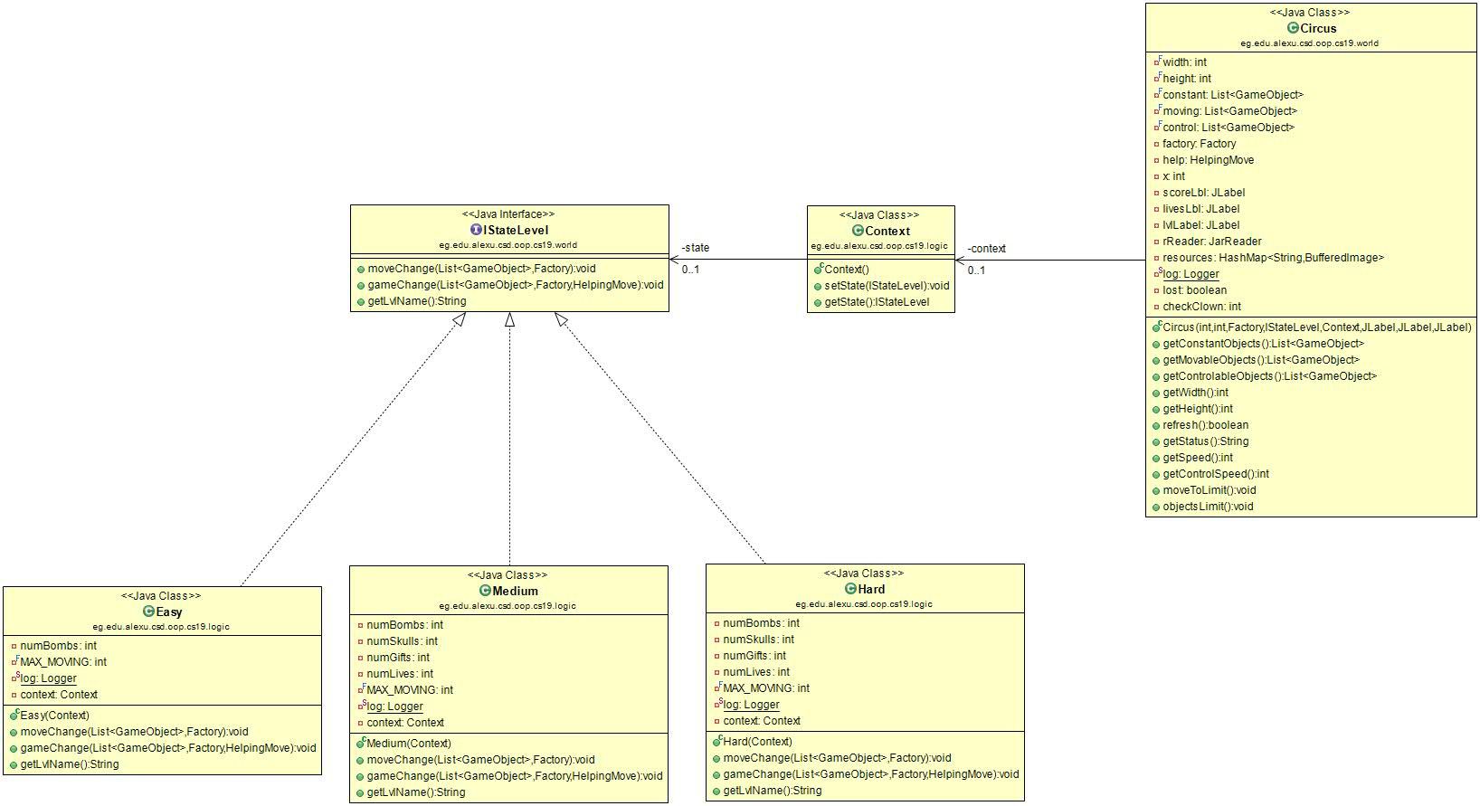

1. Strategy:

We used the strategy design pattern when the setter of the shapes are called, where there are two types of shapes: movable and controllable, and each one handles the setters differently.

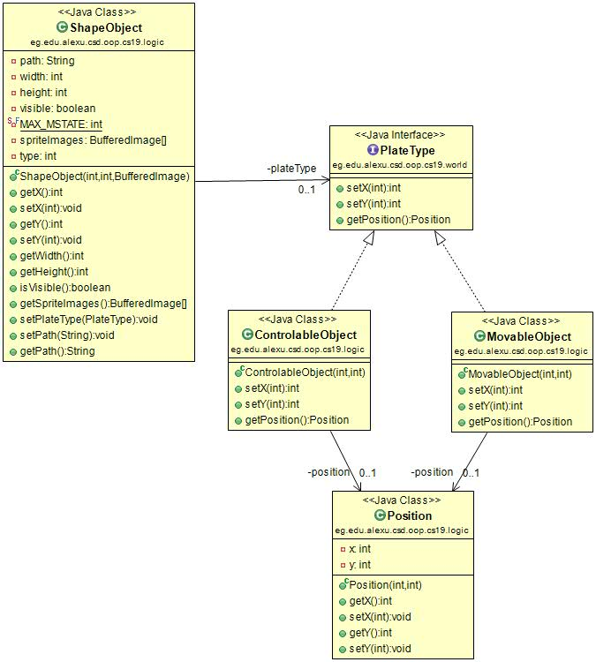

1. Flyweight:

We used the flyweight design pattern in storing the expensive data we use to build the shapes we want which in our case is the images.

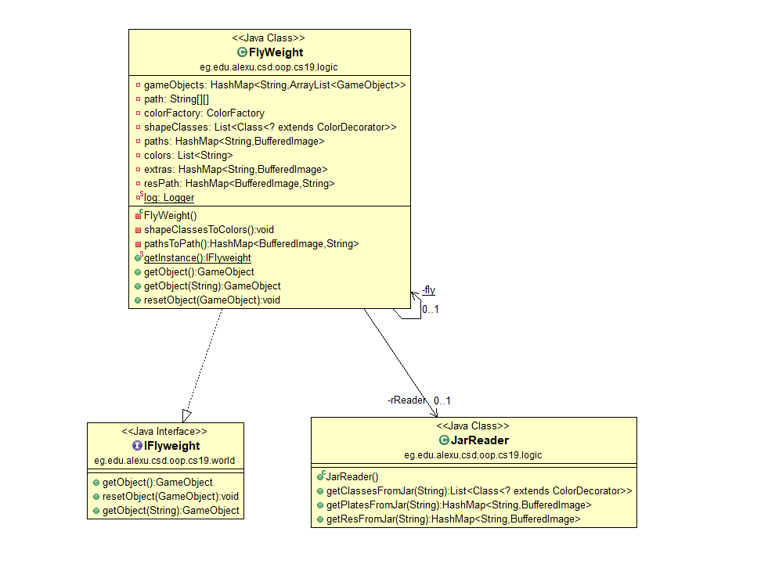

1. Observer:

We used the observer design pattern in observing the falling shapes and notifying the score, then trigger the snapshot to save the state of the stacks.

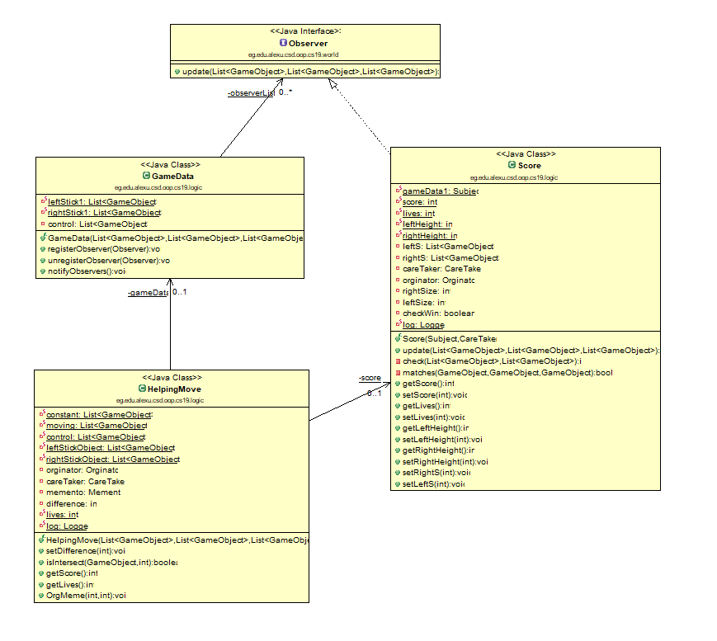

1. Decorator:

We used the decorator design pattern to know which colored shape to create and use the color factory to create the required shape object of the required color.

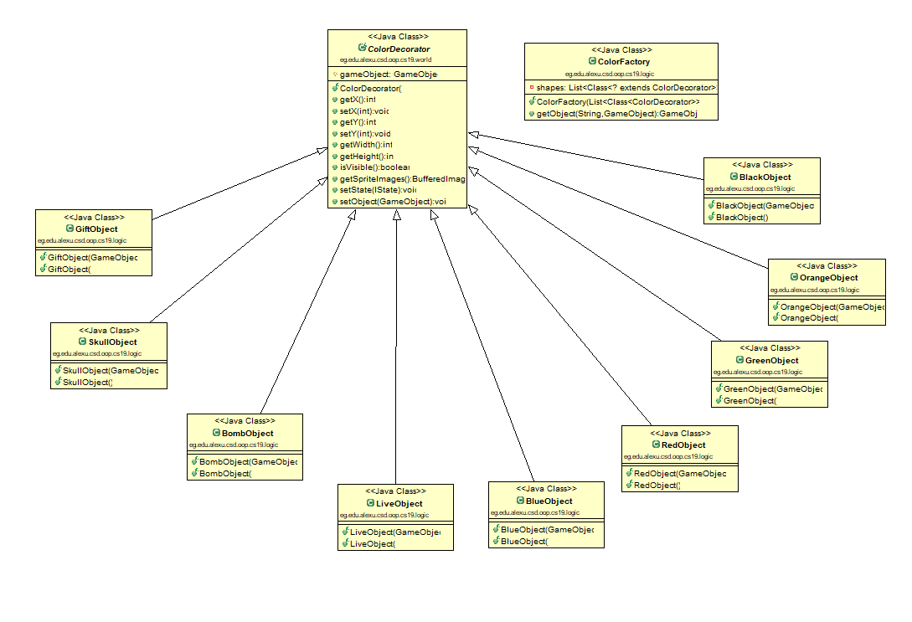

1. Template:

We used the template design pattern in making and using of the leaderboard.

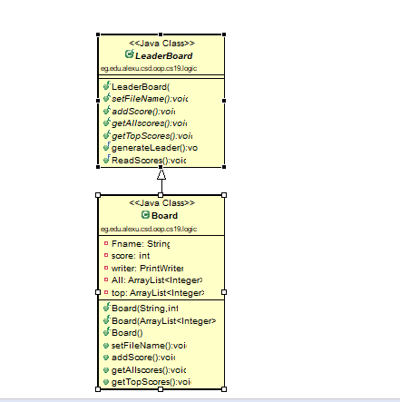

1. User Manual:

* The game starts in the easy level and the player will have 3 lives.
* The player can control the clown using the right & left arrow keys.
* The player should collect 3 consecutive plates of the same color no matter their shapes, if he does so, then 10 points will be added to his score.
* The game will then increase in its difficulty according to the player’s score till he reaches the high level where he will be in a last man standing mode, where he try to reach the maximum score he can before he die.
* The game ends either if one of the stacks he carry reaches the top of the screen or if he loses all of his lives.
* There are special gifts that fall on the player :  
  + Present: adds 50 pts to the player’s score (med, hard).
  + Bomb: remove plates from the stacks (all levels).
  + Skull: decrease the lives of the player by 1 (med, hard).
  + Extra Live: increase the lives of the player by 1 (med, hard).

1. Screenshots:

